Task Title: |  | Project
Task Code: |  | AT3

Assessment type (☒):
☐ | Questioning (Oral/Written) |  | ☐ | Portfolio
☐ | Practical Demonstration |  | ☒ | Project
☐ | 3rd Party Report |  | ☐ | Other – Please Specify
The base requirements this assessment task include:
- Computer access
- Access to Office 365 - Microsoft PowerPoint or Word (or similar)
- Access to Splunk Enterprise
- Access to Montgomery Counties online data repository. (link)

Use of some of these items may not occur in this part of the assessment task.

Assessment Due
While this assessment is due on the second last week of the course. You MUST review elements of this submission with your lecturer before submission to pass this assessment.
NOTICE: This assessment is due by session 10. This information and any updates can be found on the Learning Assessment Plan in Blackboard

Instructions
The project consists of the following parts:
- Completion of this assessment document
- Creation of a PowerPoint Presentation created using Splunk Enterprise to analyse your chosen data.
Follow the steps outlined in this document and complete the required project.
You must follow the instructions and complete the tasks for all components to complete this assessment. You may need to submit additional files.

Important
If you are unable to load and login into Splunk Enterprise, please contact your lecturer.

Scenario
Montgomery County (link)has embarked on building a 21st century program to better serve residents, employees, and other partners. The County has been an early adopter of technology and promoter of a transparent and efficient government.
Using your installation of Splunk Enterprise to build SPL queries & generate visualisations:
- The Council requires you to report and distribute research findings based on an investigation of a database of your choice from Montgomery County’s online data repository (link)
- Select one or more databases for analysis. Investigate data using a variety of search queries.
- Develop a suitable visualisation that reflects your query results. Include images of visualisation in your PowerPoint
- Discuss your visualisation in the presentation document and at least one modification to make it clearer to the audience.

- Deliver the visualisations and answers to the questions (4-8) below in the form of a report using PowerPoint or Word.

You should use the process of Data Exploration to detect Patterns, Correlations, Anomalies and Trends to build a persuasive case for change.

Specific Instructions
This file is to be submitted as a journal that demonstrates the following aspects of your competency:
- Your ability to select and analyse data.
- The ability it builds convincing visualisations from SPL queries & Splunk Dashboards
- The ability to produce a persuasive presentation, which follows a logical path to its conclusion.
Save the file as:
- XXX_VU23216_Proj.docx/pptx
Replacing XXX with your initials.
For example, Adrian Gould would use JR_VU23216_Proj.pptx for his submitted filename.
Begin by completing the form below with your details…
Assessment # and title |  |  | VU23216 |  | AT3 Project
Lecturer name |  |  | Student to fill this section out
Student name |  |  | Student to fill this section out
Student ID number |  |  | Student to fill this section out
Telephone contact number |  |  | Student to fill this section out
Email |  |  | Student to fill this section out
By completing and submitting this signed form to my lecturer, I am stating that:
- The attached submission is completely my own work
- I have correctly cited all sources of information used in this work (if required)
- I have kept a copy of this assessment (where practicable)
- I understand a copy of my assessment will be kept by the NMTAFE for their records
- I understand my assessment may be selected for use in the NMTAFE’s validation and audit process to ensure student assessment meets requirements
Student Signature | Student to fill this section out |  |  |  |  | Date |  | Student to fill this section out
Assessors please note: Where verbal clarification has been sought from a student to gather additional assessment evidence from an assessment item, question/s and response/s must be recorded, signed, and dated by the assessor, against the relevant assessment item/s.
NB: Feedback will be given via Blackboard when possible.
Submission 1 ☐ | Result | Satisfactory / Not Yet Satisfactory |  |  |  |  | Date
To satisfy requirements for this assessment, you need to complete the following: |  | Feedback to student…
Submission 2 ☐ | Result | Satisfactory / Not Yet Satisfactory |  |  |  |  | Date
To satisfy requirements for this assessment, you need to complete the following: |  | Feedback to student…
Student Feedback |  | Feedback from student…
Lecturer Signature |  |  |  | Student Signature

Answering Questions
When a step includes a question, you must attempt to answer it. A word count is sometimes given, but most answers require at most 1-3 paragraphs.
All answers must be in complete sentences unless indicated. You must use your own words unless otherwise specified.\

Reasonable Adjustment
Information on reasonable adjustment can be found in the Learning and Assessment Plan for the Unit

Recognition of Prior Learning (RPL)
Information on RPL can be found in the Learning and Assessment Plan for the Unit

Sources of Information
In industry, it is good practice to keep track of where information was obtained. This is especially true if it is a written document, or even code.
If you answer any questions using information from web sites, please include the site name and URL (Web site address) after the answer. Likewise, include the title and author for books and magazine articles. For example:
- RS Electronics Ltd: https://au.rs-online.com/
- Slack API Documentation, Users List Method: https://api.slack.com/methods/users.list

Resources for use in Assessment
The following resources are required to complete this assessment:
Assessment data
- You are required to choose at least one data set from the Montgomery Open data project here:
  - AT3 – Assessment Data (link)
- Further information on Montgomery County data strategies can be downloaded at:
  - AT3 – Montgomery County reference (link)
- When comparing the effectiveness of your data, use the New York open data project:
  - New York Open Data (link)

This space left intentionally blank

Familiarisation
- Which data sets did you select from the Open-Source repository? Please include the set name and a link to the download for the dataset.
Dataset: Seat Machine Inventory
Link: https://data.montgomerycountymd.gov/Technology/Seat-Machine-Inventory/39pa-pssi/data_preview
Enter more datasets if required…
- Describe 2 ways in which public data sets can serve Montgomery County residents, employees, and others.
Montgomery County benefits from public datasets because they make government information more accessible and enable citizens to make well-informed decisions.
Additionally, they facilitate innovation and effective services, allowing county employees, researchers, and developers to use trustworthy data to better planning, build tools, and improve community results.

Data Risks & Mitigation
- Describe 2 risks associated with publishing a public data set such as the open Montgomery Digital Government Strategy

Risks associated with publishing public datasets include privacy exposure, wherein inadequately anonymized data may disclose private personal information.

Misinterpretation or misuse is another risk. Inaccurate analysis or malevolent use of public data may propagate false information, raise security issues, or erode public confidence in governmental operations.

- Describe at least 2 mitigation strategies for addressing these risks and provide links to websites with further information on these strategies.

Implementing robust data governance, including access controls and usage auditing, and anonymizing data by eliminating personal identifiers and combining sensitive fields to prevent re-identification are two mitigation techniques.
Additional advice can be found at Open Environmental Data resources (resourcelibrary.openenvironmentaldata.org) and OAIC (oaic.gov.au).

- Is the Montgomery public data set an example of Big Data? Explain your reasoning.

Because Montgomery's public datasets are organized, manageable with common technologies, and moderately sized, they are not usually categorized as Big Data. They are useful for analysis, but they don't have the vast volume, fast speed, and variety of complexity that characterize real Big Data environments.

Patterns, discrepancies & anomalies
- Provide a search query and visualisation that demonstrates a discrepancy in a dataset. Describe the discrepancy (paste the SPL query & screenshot in the box below)

source="Seat_Machine_Inventory_20251206.csv" sourcetype="csv"
| eval MemoryMB = tonumber(Memory)
| where MemoryMB > 131072
| table Department Division "Model Name" Model# MemoryMB

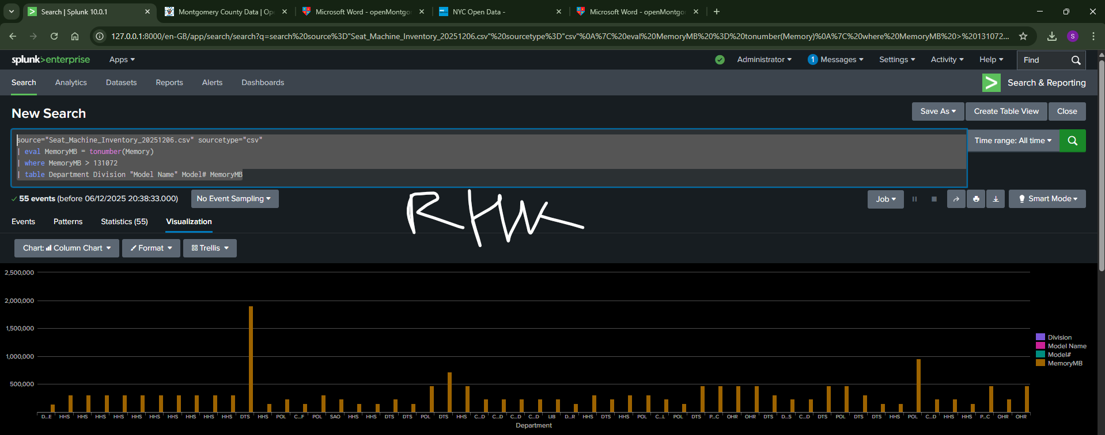

A number of devices in the dataset indicate incredibly erroneous memory values, some of which surpass one million megabytes. These anomalies indicate data corruption, invalid entry formats, or upstream system issues that need to be investigated and fixed since they deviate significantly from typical hardware requirements.

- Provide a search query and visualisation that demonstrates a trend or pattern. Describe the pattern. (paste the SPL query & screenshot in the box below)

source="Seat_Machine_Inventory_20251206.csv" sourcetype="csv"
| eval shipDate=strptime('Shipping Date',"%m/%d/%Y")
| eval year=strftime(shipDate,"%Y")
| where isnotnull(year)
| stats count BY year Description
| sort year

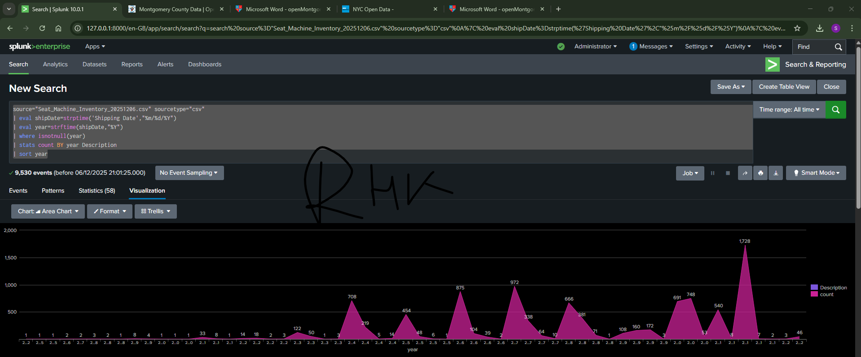
The dataset clearly demonstrates the evolution of device types: laptop deployments gradually rise in later years, while desktop deployments predominate in the early years. This gradual change points to a long-term organizational trend away from stationary workstations and toward more mobile computing options.

- Provide a search query and visualisation that demonstrates an anomaly in the dataset. Describe the anomaly. (paste the SPL query & screenshot in the box below)

source="Seat_Machine_Inventory_20251206.csv" sourcetype="csv"
| stats count BY Description
| where match(Description, "PC-Desktop|PC-DESKTOP")
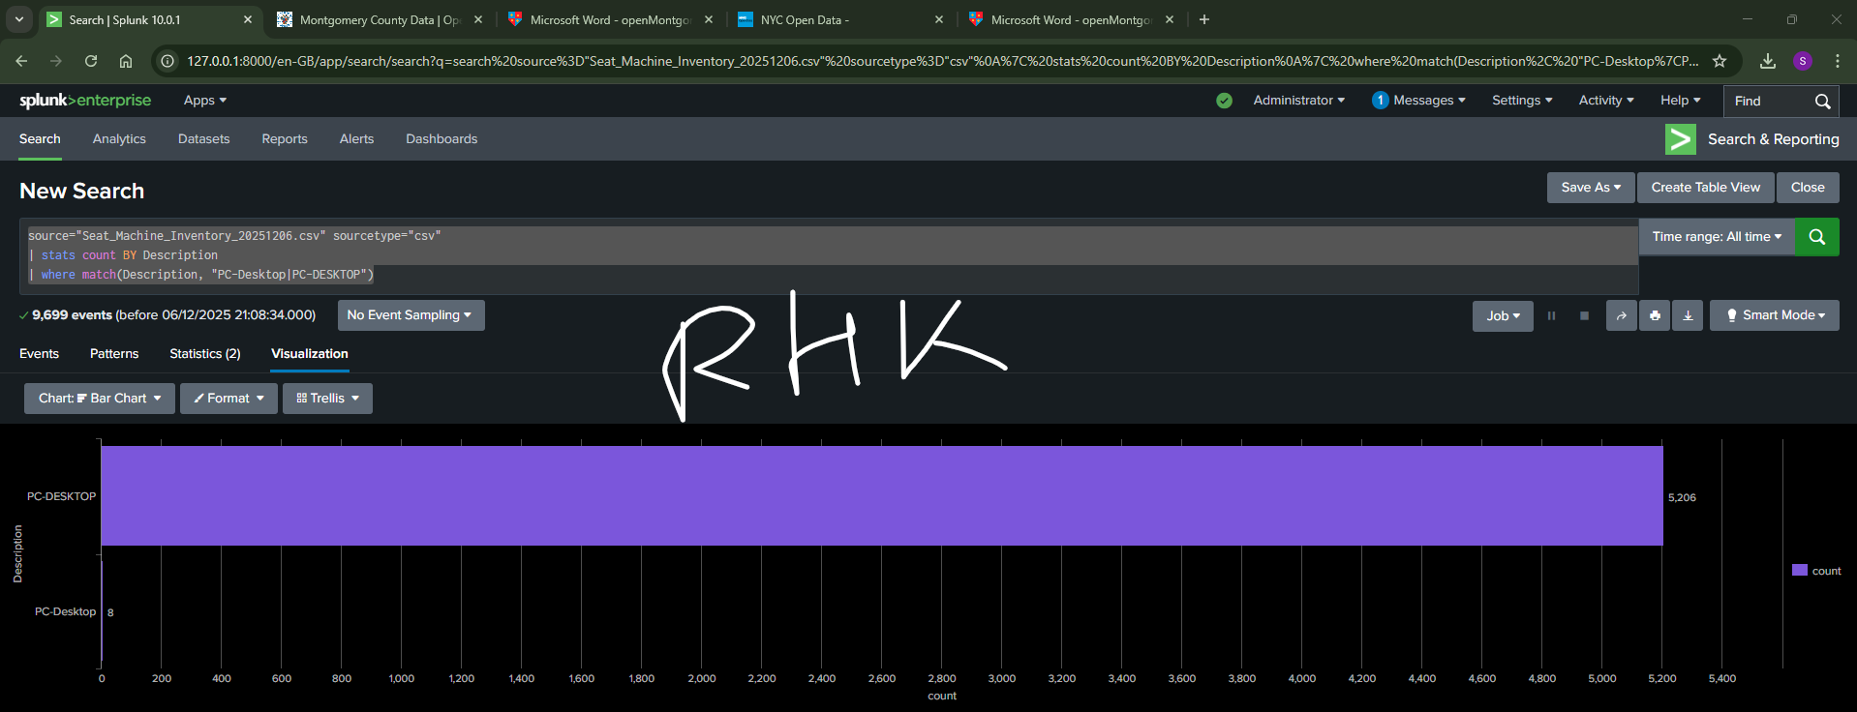

The device type name in the dataset is inconsistent; "PC-Desktop" appears alongside the typical "PC-DESKTOP," dividing what ought to be a single category. This classification anomaly shows inconsistent data entry or ingestion standards, corrupts counts, and misgroups devices.

Consider a scenario where you want to create a Splunk dashboard that displays real-time information about crime incidents in Montgomery County. How would you use the Montgomery County open data API to automate the collection and analysis of crime data for updating your Splunk dashboard? Provide step-by-step details on the automation process, including the role of Splunk and how it interacts with the API. (2-3 sentences per step, include images or screenshots to help your explanation if required).

By periodically retrieving data from the Montgomery County Open Data API, we may automate real-time crime updates in Splunk.
First, create a little script that makes a few-minute call to the crime endpoint of the API, requesting only occurrences that have been added since the last check.
The recovered crime data should then be sent to Splunk via the HTTP Event Collector, where Splunk indexes fields such as incident type, time, and location.
The dashboard is then automatically updated by Splunk through searches that feed panels like recent-incident tables, trend charts, and live maps.
The Splunk dashboard refreshes and new offenses are ingested while the script keeps polling the API, giving you constantly updated data without the need for human interaction.

Final steps
Finally, submit your presentation with this document and all the best!

You DID IT!!!
Well done on completing this project!
You’ve come a long way.

